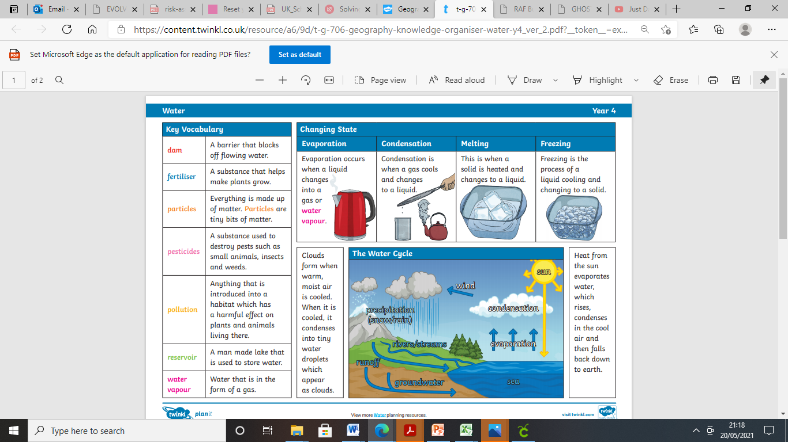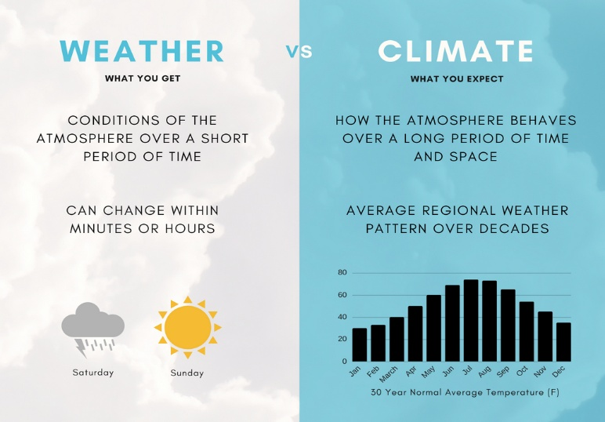

What are the different forms of water?

WATER AND THE WEATHER

What is the difference between climate and weather?