of the four season
Important Facts

- Autumn is one of the four seasons.
- Autumn is in the months of September, October and November.
- The days become shorter and it gets dark earlier.
- The leaves turn from green to red, yellow and brown.
- Hedgehogs go to sleep in the winter, this is called hibernation.
- Autumn can be rainy, windy and foggy.
- Many people around the world celebrate festivals of light.

Key vocab

Autumn
Light
dark
Season
Conker
Leaf
Hibernate
festival

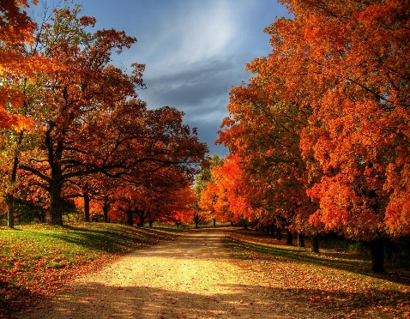

Autumn
Da ys
Researching the topic
ht Autumn - BBC Bitesize

The leaf thief-Alice Hemming

Fletcher and the falling leaf –Julia Rawlinson

Non- fiction on animals in autumn

Books on Diwali and Hanukah

All non-fiction books on seasons and Autumn

Meet Pete by Jennifer Campbell

Clarabelle

(Autumn 2)
Places to visit

- The park
- Tatton Park
- A garden centre
- A hedgehog rescue centre

Science Skills

To understand what the signs of autumn are.

PSHE / Citizenship Skills

To gain a greater insight into how different faiths celebrate light.
they are important.

A picture to share with an adult and discuss what you can see

