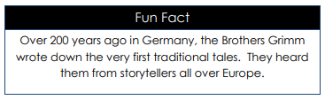
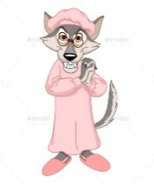
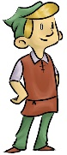
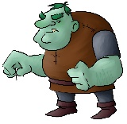



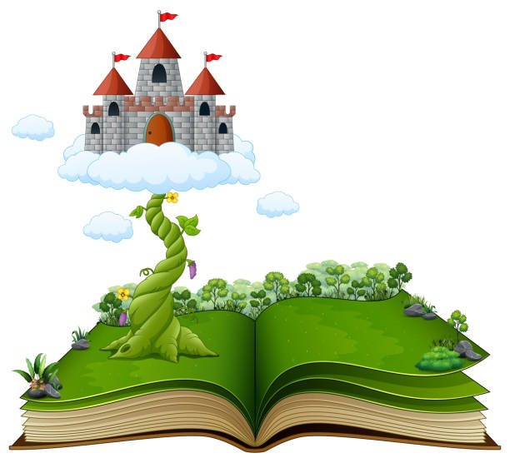
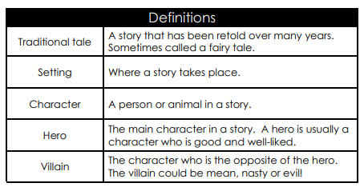
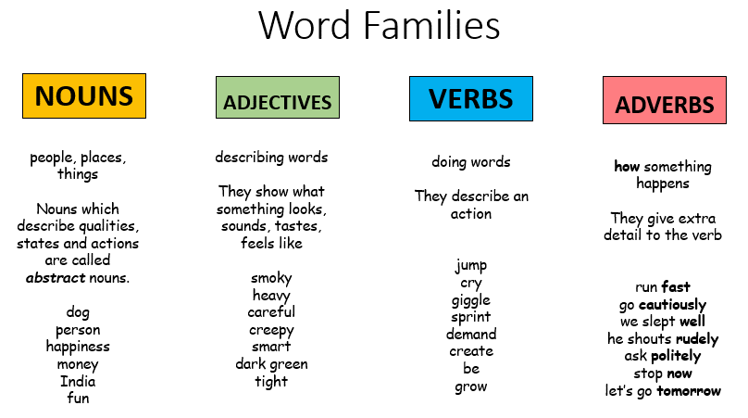
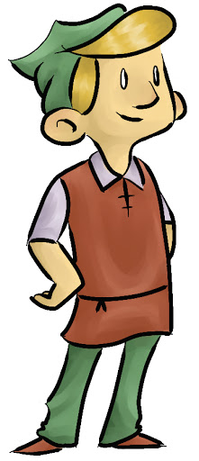
Word Families
Can you read or retell any of the Grimm brothers’ fairy tales?
Rapunzel
Rumpelstiltskin
Cinderella
Snow White
The Golden Goose
Hansel and Gretel
Thumbelina
The Frog Prince
The Elves & the Shoemaker

Once upon a fairy tale…
Knowledge Organiser
Over 200 years ago in Germany, the Brothers Grimm wrote down the very first traditional tales. They heard them from storytellers all over Europe.
Nearly all traditional fairy tales have morals within them. This means that the tale teaches us an important lesson.
How something happens

They give extra detail to the verb

run fast
go cautiously
he slept well
he shouts rudely
ask politely
stop now
let’s go tomorrow
Doing words

They describe an action

jump
cry
giggle
sprint
demand
create
be
grow
Describing words

They show what something looks, sounds, tastes, feels like

smoky
heavy
careful
creepy
Smart
dark green
tight
People, places, things
Nouns which describe qualities. States and actions are called abstract nouns
dog
person
happiness
money
India
fun

