Green Class Knowledge Organiser - Spring 2

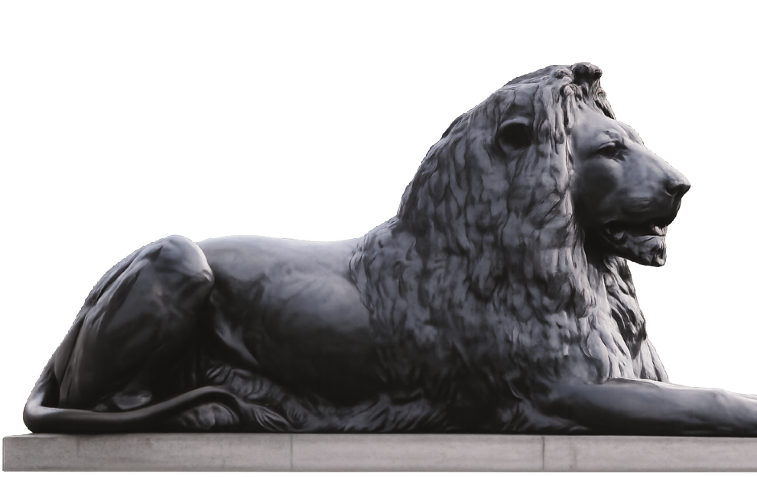

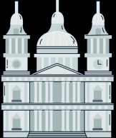
Katie in London
Word Mat
Katie In London
Nouns
London
city
lion
museum
palace
crown
guard
bus
river
bridge
Adjectives
b
ig
busy
tall
shiny
golden
noisy
famous
proud
brave
beautiful
Verbs
walke
d
looked
climbed
travelled
explored
visited
found
waved
marched
roared
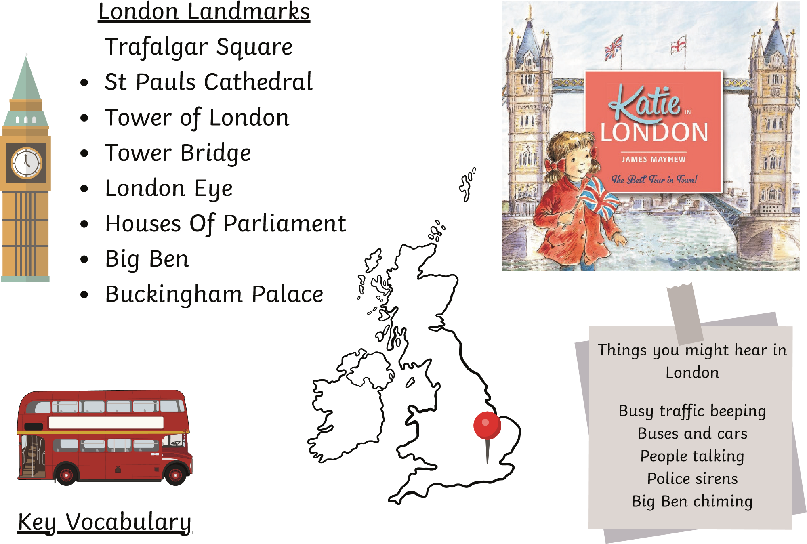
London - The capital city of England and the United Kingdom.
City – A very big town with lots of people, buildings and places to visit.
Capital city – The main city of a country. London is the capital city of the United Kingdom.
Museum – A place where we can go to see and learn about old and interesting objects.
Cathedral – A very large and important church.
Palace – A big, beautiful home where a king or queen lives.
Crown Jewels – Very special and valuable crowns and treasures that belong to the king or queen.

