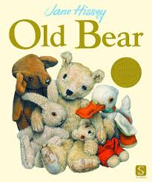
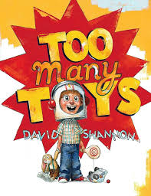
- Children have always played with toys but toys have changed through the years.
- Toys have changed as new materials and technology has been invented.
- Toys used to be made from wood, metal and cloth but now we often play with plastic toys, including those with batteries.
- Toys can be made from many different materials such as stone, wood, clay, iron or plastic. The oldest toys ever found were made from antler horn and soft rock.
- People have always played with toys but many toys evolved over time. This means that as new and more exciting toys are invented, some toys from the past are no longer played with or considered exciting.
- As more families have moved to England over time, British children play with more toys that have been brought from around the world.
- Lego was invented in 1947 by Ole Kirk Christiansen in Denmark. It used to be made from wood but is now made from plastic.

Interesting information!
Topic overview
In this history topic, we will be travelling through time to investigate toys through many generations.
Stories to share:


Key Vocabulary
- Old- having existed for many years; not new.
- New- having recently arrived, been produced, or come into being.
- Past- having happened or gone by at an earlier time.
- Present- existing at this time; current.
- Generation- a group of people: children, parents, grandparents.

