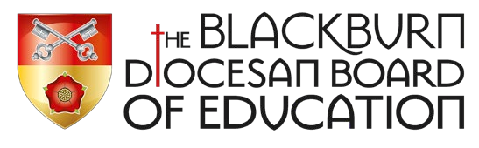 | QUESTFUL RE  COMMUNITY SCHOOLS
Below is an example of how you could structure your Key Stage 1 RE Curriculum.
The black type is the Unit Title and Christianity question.
The mustard type is the World Faith question.
The red type indicates which world faiths could be studied.

KS1 | Autumn | Spring | Summer
Year 1 | 1.1 Harvest: How can we help those who do not have a good harvest?  How do people of  Jewish faith celebrate the harvest?  Judaism  1.9 My world Jesus world: How is the place where Jesus lived different from how we live now?  Judaism  1.3 Christmas: Why do we give and receive gifts?  Hinduism Islam | 1.4 Jesus: What made Jesus special?  1.5 Easter: What do you think is the most important part of the Easter story? | 1.7 Baptism: Why is baptism special? How do people of world faiths welcome new babies?  Hinduism Islam Sikhism  1.2 Creation: What are your favourite things that God created?  What do people of Muslim and Hindu faith believe about how God made the world?  Hinduism Islam
Year 2 | 2.1 The Bible: Why is the Bible such a special book? Do people of all world faiths have holy books?  Islam Judaism  Sikhism  2.2 Christmas: Why was the birth of Jesus such good news? | S9 New Testament: Which part of the story do you like best? What is the most important part of the story? Hindu Islam Judaism Sikhism  2.4 Easter: How do Symbols help us understand the Easter story? | 2.6 Ascension and Pentecost: What happened at the  Ascension and Pentecost?  2.5 The Church: Why is the church a special place for Christians?  Why are holy buildings important to people of faith?  Hinduism Islam Judaism

