BEWSEY LODGE PRIMARY SCHOOL

Positive Behaviour Policy (including statement of behaviour principles)

Date of Review | September 2023
Date of next Review | September 2026

Contents
1. Aims 2
2. Legislation, statutory requirements and statutory guidance 2
3. Definitions 3
4. Roles and responsibilities 4
5. School behaviour curriculum 5
6. Responding to behaviour 6
7. Supporting pupils following a sanction……………………………………………………………………………….7
8. Responding to unacceptable and challening behaviour from pupils with SEND 7
9. Specific behaviour issues…………………………………………………………………………………..…………8
10. Pupil transition 11
11. Monitoring arrangements 11
12. Safeguarding…………………………………………………………………………………………………………12

Appendices
Appendix 1: School Charter…………………………………………………………………………………………… 13
Appendix 2: Written statement of behaviour principles 14
Appendix 3: Home/school agreement ………………………………………………………………………………...15
Appendix 4: Traffic light system……………………………………………………………………………………….16
Appendix 5: lunchtime behaviour System…………………………………………………………………………….17

1. Aims
This policy aims to:
- Create a positive culture that promotes excellent behaviour, ensuring that all pupils have the opportunity to learn in a calm, safe and supportive environment
- Establish a whole-school approach to maintaining high standards of behaviour that reflect the values of the school
- Outline the expectations and consequences of behaviour
- Provide a consistent approach to behaviour management that is applied equally to all pupils
- Define what we consider to be unacceptable behaviour

2. Legislation, statutory requirements and statutory guidance
This policy is based on legislation and advice from the Department for Education (DfE) on:
- Behaviour and discipline in schools: advice for headteachers and school staff, 2016
- Behaviour in schools: advice for headteachers and school staff 2022
- Searching, screening and confiscation at school 2018
- Searching, screening and confiscation: advice for schools 2022
- The Equality Act 2010
- Keeping Children Safe in Education
- Exclusion from maintained schools, academies and pupil referral units in England 2017
- Suspension and permanent exclusion from maintained schools, academies and pupil referral units in England, including pupil movement - 2022
- Use of reasonable force in schools
- Supporting pupils with medical conditions at school
- Special Educational Needs and Disability (SEND) Code of Practice.
- Section 175 of the Education Act 2002, which outlines a school’s duty to safeguard and promote the welfare of its pupils
- Sections 88 to 94 of the Education and Inspections Act 2006, which requires schools to regulate pupils’ behaviour and publish a behaviour policy and written statement of behaviour principles, and give schools the authority to confiscate pupils’ property

3. Definitions
Unacceptable behaviour is defined as:
- Children not following the school charter (see appendix 1)
Challenging behaviour is defined as:
- Repeated breaches of the school charter
- Any form of bullying (see anti-bullying policy)
- Sexual violence or sexual assault (intentional sexual touching without consent)
- Sexual harassment, meaning unwanted conduct of a sexual nature, such as:
- Sexual comments
- Sexual jokes or taunting
- Physical behaviour like interfering with clothes
- Online sexual harassment, such as unwanted sexual comments and messages (including on social media), sharing of nude or semi-nude images and/or videos, or sharing of unwanted explicit content
- Vandalism
- Theft
- Fighting
- Smoking/vaping
- Racist, sexist, homophobic or discriminatory behaviour
- Possession of any prohibited items. These are:
- Knives or weapons
- Alcohol
- Illegal drugs
- Stolen items
- Tobacco and cigarette papers/ vapes/ e-cigs
- Fireworks
- Pornographic images
- Any article a staff member reasonably suspects has been, or is likely to be, used to commit an offence, or to cause personal injury to, or damage to the property of, any person (including the pupil)

4. Roles and responsibilities
4.1 The governing board
The Governing Body is responsible for:
- Reviewing and approving the written statement of behaviour principles (appendix 2)
- Reviewing this behaviour policy in conjunction with the Headteacher
- Monitoring the policy’s effectiveness
- Holding the Headteacher to account for its implementation
4.2 The Headteacher
The Headteacher is responsible for:
- Reviewing this policy in conjunction with the Governing Body, giving due consideration to the school’s statement of behaviour principles (appendix 2)
- Approving this policy
- Ensuring that the school environment encourages positive behaviour
- Ensuring that staff deal effectively with poor behaviour
- Monitoring that the policy is implemented by staff consistently with all groups of pupils
- Ensuring that all staff understand the behavioural expectations and the importance of maintaining them
- Providing new staff with a clear induction into the school’s behavioural culture to ensure they understand its rules and routines, and how best to support all pupils to participate fully
- Offering appropriate training in behaviour management, and the impact of special educational needs and disabilities (SEND) and mental health needs on behaviour, to any staff who require it, so they can fulfil their duties set out in this policy
- Ensuring this policy works alongside the safeguarding policy to offer pupils both sanctions and support when necessary
- Ensuring that CPOMS data is reviewed regularly, to make sure that no groups of pupils are being disproportionately impacted by this policy
4.3 Teachers and staff
Staff are responsible for:
- Creating a calm and safe environment for pupils
- Establishing and maintaining clear boundaries of acceptable pupil behaviour
- Implementing the behaviour policy consistently
- Communicating the school’s expectations, routines, values and standards through teaching behaviour and in every interaction with pupils
- Modelling expected behaviour and positive relationships
- Providing a personalised approach to the specific behavioural needs of particular pupils
- Considering their own behaviour on the school culture and how they can uphold school rules and expectations
- Recording behaviour incidents promptly
- Challenging pupils to meet the school’s expectations
The senior leadership team (SLT) will support staff in responding to behaviour incidents.
4.4 Parents and carers
Parents and carers, where possible, should:
- Get to know the school’s behaviour policy and reinforce it at home where appropriate
- Sign and return the home-school agreement (appendix 3)
- Support their child in adhering to the school’s behaviour policy
- Inform the school of any changes in circumstances that may affect their child’s behaviour
- Discuss any behavioural concerns with the class teacher promptly
- Raise any concerns about the management of behaviour with the school directly, whilst continuing to work in partnership with the school
- Take part in the life of the school and its culture
The school will endeavour to build a positive relationship with parents and carers by keeping them informed about developments in their child's behaviour and the school’s policy, and working in collaboration with them to tackle behavioural issues.
4.5 Pupils
Pupils will be made aware of the following during their induction into the behaviour culture:
- The expected standard of behaviour they should be displaying at school
- That they have a duty to follow the behaviour policy
- The school charter
- The rewards they can earn for meeting the behaviour standard, and the consequences they will face if they don’t meet the standard
- The pastoral support that is available to them to help them meet the behavioural standards

5. School behaviour curriculum
At Bewsey Lodge Primary School, development of the whole child is at the heart of all that we do. Our aim is to develop children who are confident, healthy and happy. Children who persevere and take risks; who have a voice and respect themselves and the lives and cultures of others. We have high expectations of behaviour from all of our children and through our curriculum, they are given every opportunity to understand these expectations through a range of teaching techniques including: modelling, discussion and practice.

Pupils are expected to:
- Behave in an orderly and self-controlled way
- Show respect to members of staff and each other
- In class, make it possible for all pupils to learn
- Move quietly around the school
- Treat the school buildings and school property with respect
- Wear the correct uniform at all times
- Accept sanctions when given
- Refrain from behaving in a way that brings the school into disrepute, including when outside school or online
Where appropriate and reasonable, adjustments may be made to routines within the curriculum to ensure all pupils can meet behavioural expectations in the curriculum.

6. Responding to behaviour
6.1 Responding to good behaviour
When a pupil’s behaviour meets or goes above and beyond the expected behaviour standard, staff will recognise it with positive recognition and reward. This provides an opportunity for all staff to reinforce the school’s culture and ethos.
Positive reinforcements and rewards will be applied clearly and fairly to reinforce the routines, expectations and norms of the school’s behaviour culture.
Positive behaviour will be rewarded with:
- Diddy dots –sticker collection to earn prizes
- Dojos
- House points
- Special Achievement Assemblies
- Praise – visual or verbal including stickers and comments in books
- Positions of responsibilities
- Child of the term awards (termly)
- Special jobs
6.2 Responding to unacceptable behaviour
When a pupil’s behaviour falls below the standard that can reasonably be expected of them, staff will respond in order to restore a calm and safe learning environment, and to prevent recurrence of misbehaviour.
Staff will endeavour to create a predictable environment by always challenging behaviour that falls short of the standards, and by responding in a consistent, fair and proportionate manner, so pupils know with certainty that misbehaviour will always be addressed.
De-escalation techniques can be used to help prevent further behaviour issues arising, such as the use of pre-arranged scripts and phrases.
All pupils will be treated equitably under the policy, with any factors that contributed to the behavioural incident identified and taken into account.
When giving behaviour sanctions, staff will also consider what support could be offered to a pupil to help them to meet behaviour standards in the future.
The school may use 1 or more of the following sanctions in response to unacceptable behaviour:
- The traffic light system (see appendix 4)
- Lunchtime behaviour system (see appendix 5)
- A verbal reprimand and reminder of the expectations of behaviour
- Setting of written tasks such as an account of their behaviour
- Expecting work to be completed at home, or at break or lunchtime
- Reflection at break or lunchtime
- Restorative 1-1/small group intervention
- Loss of privileges – for instance, the loss of a responsibility
- School-based community service, such as tidying a classroom
- Referring the pupil to a senior member of staff
- Letter or phone call home to parents/carers
- Agreeing a behaviour contract
- Removal of the pupil from the classroom
- Use of reasonable force (see Positive Handling Policy)
- Suspension
- Permanent exclusions, in the most serious of circumstances
6.3 Suspension and permanent exclusions
The school can use suspension and permanent exclusion in response to serious incidents or in response to persistent poor behaviour, which has not improved following in-school sanctions and interventions.
The decision to suspend or exclude will be made by the Headteacher and only as a last resort.
For further guidance please see the following document; Exclusion from maintained schools, academies and pupil referral units in England, (https://www.gov.uk/government/publications/school-exclusion).

7. Supporting pupils following a sanction
Following a sanction, the school will consider strategies to help pupils to understand how to improve their behaviour and meet the expectations of the school.
This could include measures such as:
- Reintegration meetings
- Daily contact with a key member of staff
- Targeted intervention/support
- Communication book between home and school

8. Responding to unacceptable and challenging behaviour from pupils with SEND
8.1 Recognising the impact of SEND on behaviour
The school recognises that pupils’ behaviour may be impacted by a special educational need or disability (SEND). When incidents of misbehaviour arise, we will consider them in relation to a pupil’s SEND, although we recognise that not every incident of misbehaviour will be connected to their SEND. Decisions on whether a pupil’s SEND had an impact on an incident of misbehaviour will be made on a case-by-case basis.
When dealing with misbehaviour from pupils with SEND, especially where their SEND affects their behaviour, the school will balance their legal duties when making decisions about enforcing the behaviour policy. The legal duties include:
- Taking reasonable steps to avoid causing any substantial disadvantage to a disabled pupil caused by the school’s policies or practices (Equality Act 2010)
- Using our best endeavours to meet the needs of pupils with SEND (Children and Families Act 2014)
- If a pupil has an education, health and care (EHC) plan, the provisions set out in that plan must be secured and the school must co-operate with the local authority and other bodies
As part of meeting these duties, the school will anticipate, as far as possible, all likely triggers of misbehaviour, and put in place support to prevent these from occurring.
Any preventative measures will take into account the specific circumstances and requirements of the pupil concerned, these may include:
- Short, planned movement breaks for a pupil with SEND who finds it difficult to sit still for long periods of time
- Adjusting seating plans to allow a pupil with visual or hearing impairment to sit near the teacher
- Adjusting uniform requirements for a pupil with sensory issues or who has severe eczema
- Training for staff
- Use of quiet spaces where pupils can regulate their emotions during a moment of sensory overload
8.2 Adapting sanctions for pupils with SEND
When considering a behavioural sanction for a pupil with SEND, the school will take into account:
- Whether the pupil was unable to understand the rule or instruction?
- Whether the pupil was unable to act differently at the time as a result of their SEND?
- Whether the pupil is likely to behave aggressively due to their particular SEND?
If the answer to any of these questions is yes, it may be unlawful for the school to sanction the pupil for the behaviour.
The school will then assess if it is appropriate to use a sanction and if so, whether any reasonable adjustments need to be made to the sanction.
8.3 Considering whether a pupil displaying challenging behaviour may have unidentified SEND
The school’s special educational needs co-ordinator (SENCO) may evaluate a pupil who exhibits challenging behaviour to determine whether they have any underlying needs that are not currently being met.
Where necessary, support and advice will also be sought from specialist teachers, an educational psychologist, medical practitioners and/or others, to identify or support specific needs.
When acute needs are identified in a pupil, we will liaise with external agencies and plan support programmes for that child. We will work with parents/carers to create the plan and review it on a regular basis.
8.4 Pupils with an education, health and care (EHC) plan
The provisions set out in the EHC plan must be secured and the school will co-operate with the local authority and other bodies.
If the school has a concern about the behaviour of a pupil with an EHC plan, it will make contact with the local authority to discuss the issue. If appropriate, the school may request an emergency/early review of the EHC plan.

9. Specific behaviour issues
9.1 Mobile phones
If it is necessary to bring a mobile phone into school, it would be expected that the phone is kept in the child’s bag and is turned off until they have left school grounds. The school will not accept any damage caused to any device brought into school.
9.2 Confiscation, searches, screening
Searching, screening and confiscation is conducted in line with the DfE’s latest guidance on searching, screening and confiscation.

9.3 Confiscation
Any prohibited items (listed in section 3) found in a pupil’s possession as a result of a search will be confiscated. These items will not be returned to the pupil.
We will also confiscate any item that is harmful or detrimental to school discipline. These items will be returned to pupils after discussion with senior leaders and parents/carers, if appropriate.
9.4 Searching a pupil
Searches will only be carried out by a member of staff who has been authorised to do so by the Headteacher, or by the Headteacher themselves. The consent of a parent/carer will be sought unless there is immediate risk to the child or other children/staff.
Subject to the exception below, the authorised member of staff carrying out the search will be of the same sex as the pupil, and there will be another member of staff present as a witness to the search.
An authorised member of staff of a different sex to the pupil can carry out a search without another member of staff as a witness if:
- The authorised member of staff carrying out the search reasonably believes there is risk that serious harm will be caused to a person if the search is not carried out as a matter of urgency; and
- In the time available, it is not reasonably practicable for the search to be carried out by a member of staff who is the same sex as the pupil; or
- It is not reasonably practicable for the search to be carried out in the presence of another member of staff.
When an authorised member of staff conducts a search without a witness they should immediately report this to another member of staff, and ensure a written record of the search is kept.
If the authorised member of staff considers a search to be necessary, but is not required urgently, they will seek the advice of the Headteacher, Designated Safeguarding Lead (DSL), who may have more information about the pupil. During this time the pupil will be supervised and kept away from other pupils.
A search can be carried out if the authorised member of staff has reasonable grounds for suspecting that the pupil is in possession of a prohibited item or any item identified in the school rules for which a search can be made, or if the pupil has agreed.
An appropriate location for the search will be found. Where possible, this will be away from other pupils. The search will only take place on the school premises or where the member of staff has lawful control or charge of the pupil, for example on a school trip.
Searching pupils’ possessions
Possessions means any items that the pupil has or appears to have control of, including:
- Desks
- Lockers
- Bags
A pupil’s possessions can be searched for any item if the pupil agrees to the search. If the pupil does not agree to the search, staff can still carry out a search for prohibited items (listed in section 3) and items identified in the school rules.
An authorised member of staff can search a pupil’s possessions when the pupil and another member of staff are present.
If there is a serious risk of harm if the search is not conducted immediately, or it is not reasonably practicable to summon another member of staff, the search can be carried out by a single authorised member of staff.
Informing the DSL
The staff member who carried out the search should inform the DSL without delay.

Informing parents/carers
Parents/carers will always be informed of any search for a prohibited item (listed in section 3). A member of staff will tell the parents/carers as soon as is reasonably practicable:
- What happened & why
- What was found, if anything
- What has been confiscated, if anything
- What action the school has taken, including any sanctions that have been applied to their child
Support after a search
Irrespective of whether any items are found as the result of any search, the school will consider whether the pupil may be suffering or likely to suffer harm and whether any specific support is needed (due to the reasons for the search, the search itself, or the outcome of the search).
If this is the case, staff will follow the school’s safeguarding policy and speak to the DSL. The DSL will consider if pastoral support, an early help intervention or a referral to children’s social care is appropriate.
9.5 Strip searches
The authorised member of staff’s power to search outlined above does not enable them to conduct a strip search (removing more than the outer clothing) and strip searches on school premises shall only be carried out by police officers in accordance with the Police and Criminal Evidence Act 1984 (PACE) Code C.
9.6 Unacceptable behaviour off-site including online
Sanctions may be applied where a pupil has demonstrated unacceptable behaviour when representing the school. This means misbehaviour when the pupil is:
- Taking part in any school-organised or school-related activity (e.g. school trips)
- Travelling to or from school
- Wearing school uniform
- In any other way identifiable as a pupil of our school
Sanctions (such as those listed in section 6.2) may also be applied where a pupil has misbehaved off-site, at any time, whether or not the conditions above apply, if the misbehaviour:
- Could have repercussions for the orderly running of the school
- Poses a threat to another pupil
- Could adversely affect the reputation of the school
Sanctions will only be given out on school premises or elsewhere when the pupil is under the lawful control of a staff member (e.g. on a school-organised trip).
9.7 Suspected criminal behaviour
If a pupil is suspected of criminal behaviour, the school will make an initial assessment of whether to report the incident to the police.
9.8 Zero-tolerance approach to sexual harassment and sexual violence
The school will ensure that all incidents of sexual harassment and/or violence are met with a suitable response, and never ignored.
Pupils are encouraged to report anything that makes them uncomfortable, no matter how ‘small’ they feel it might be.
The school’s response will be:
- Proportionate
- Considered
- Supportive
- Decided on a case-by-case basis
The school has procedures in place to respond to any allegations or concerns regarding a child’s safety or wellbeing. These include clear processes for:
- Responding to a report
- Carrying out risk assessments, where appropriate, to help determine whether to:
  - Manage the incident internally
  - Refer to early help
  - Refer to children’s social care
  - Report to the police
Please refer to our child protection policy.
9.9 Malicious allegations
Where a pupil makes an allegation against a member of staff and that allegation is shown to have been deliberately invented or malicious, the school will consider whether to discipline the pupil in accordance with this policy.
Where a pupil makes an allegation of sexual violence or sexual harassment against another pupil and that allegation is shown to have been deliberately invented or malicious, the school will consider whether to discipline the pupil in accordance with this policy.
In all cases where an allegation is determined to be unsubstantiated, unfounded, false or malicious, the school (in collaboration with the local authority designated officer (LADO), where relevant) will consider whether the pupil who made the allegation is in need of help, or the allegation may have been a cry for help. If so, a referral to children’s social care may be appropriate.
The school will also consider the pastoral needs of staff and pupils accused of misconduct.

10. Pupil transition
10.1 Inducting incoming pupils
The school will support incoming pupils to meet behaviour standards by offering an induction pack to familiarise them with the behaviour policy and the wider school culture.
10.2 Preparing outgoing pupils for transition
To ensure a smooth transition to the next year, pupils have transition sessions with their new teacher(s). In addition, staff members hold transition meetings.
To ensure behaviour is continually monitored and the right support is in place, information related to pupil behaviour issues may be transferred to relevant staff at the start of the term or year.

11. Monitoring arrangements
11.1 Monitoring and evaluating school behaviour
The school will collect data on the following:
- Behavioural incidents, including removal from the classroom
- Attendance, permanent exclusion and suspension
- Use of pupil support units, off-site directions and managed moves
- Incidents of searching, screening and confiscation
- Anonymous surveys for staff, pupils, governors, trustees and other stakeholders on their perceptions and experiences of the school behaviour culture
The data will be analysed regularly by members of SLT. The school will use the results of this analysis to make sure it is meeting its duties under the Equality Act 2010. If any trends or disparities between groups of pupils are identified by this analysis, the school will review its policies to tackle it.

13. Safeguarding
The school recognises that changes in behaviour may be an indicator that a pupil is in need of help or protection.
We will consider whether a pupil’s behaviour may be linked to them suffering, or being likely to suffer, significant harm.
Where this may be the case, we will follow our child protection and safeguarding policy, and consider whether pastoral support, an early help intervention or a referral to children’s social care is appropriate.
Please refer to our child protection and safeguarding policy for more information.

Appendix 1: School Charter – currently being written for the new school year
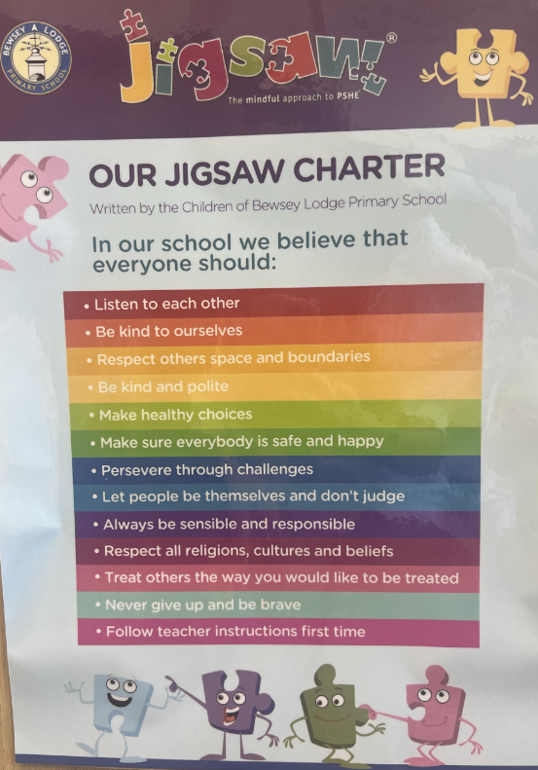

Appendix 2: Statement of behaviour principles

- All pupils, staff and visitors have the right to feel safe at all times in School
- Bewsey Lodge Primary is an inclusive School. All members of the School community should be free from discrimination of any sort. Measures to protect pupils are set out in the Positive Behaviour Policy and Equality and Accessibility Policy
- All Policies underpin our ethical values of openness, honesty, social responsibility and caring for others
- School rules are clearly set out in the Positive Behaviour Policy and displayed around School. Governors expect these rules to be consistently applied by all staff
- Governors would like to see a wide range of rewards, consistently and fairly applied in such a way as to encourage and reward good behaviour around School
- Sanctions for unacceptable/poor behaviour should be known and understood by all staff and pupils and consistently applied. We recognise that the use of rewards and sanctions must have regard for the individual situation and the individual pupil and that School staff will use their discretion in their use. Sanctions should be applied fairly, consistently, proportionally and reasonably, taking into account SEND, disability and the needs of vulnerable pupils, and offering support if necessary
- The Governors expect pupils and parents/carers to co-operate to maintain an orderly climate for learning
- The Governors wish to emphasise that violence, threatening behaviour or abuse by pupils or parents/carers towards School’s staff will not be tolerated
- The Governors expect the Head Teacher to include guidance on the use of reasonable force (see Positive Handling Policy)
- For further details on all matters concerning behaviour, please refer to the Positive Behaviour Policy

Appendix 3: Home School Agreement

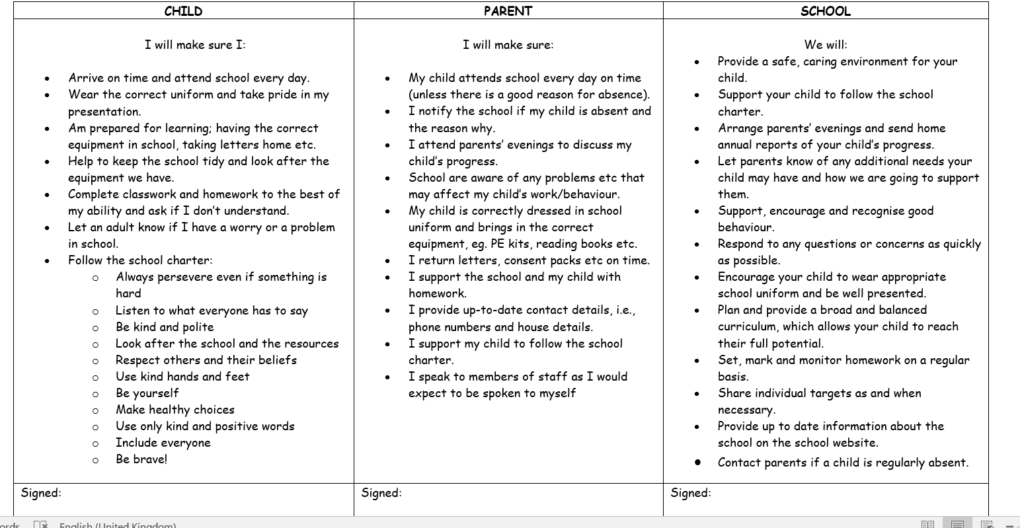

Appendix 4: Traffic light system
What staff will do | What the child will do | What we will say to the child
 | All children start each session on green (morning and afternoon)
 | Primary behaviour* e.g. shouting out  1st warning | This might be a ‘No thank you!’ ‘Look!’
Move to black  (if behaviour is deemed severe enough then staff have the option of moving a child straight to amber) | Child shouts out again  2nd warning | ‘You have chosen for your name to be moved to black by XXX.  This is your 2nd warning. Next time you will move to amber. It is your choice.’
Move to amber  Mark on behaviour log | Child shouts out again  3rd warning | ‘You have chosen for your name to be moved to amber by XXX and will miss your next playtime and go into Reflection/stay in your classroom.  Next time you will move to red. It is your choice’ (Reception have their name moved only).
Move to red  Mark on behaviour log  Parents/carers informed in person or by telephone  The child may lose privileges such as after school club, school trip | Child shouts again  4th warning | ‘You have chosen for your name to be moved to red by XXX and will work for 15 minutes in X’s classroom (a member of the Senior Leadership Team) and go into Reflection/stay in your classroom (Reception; …and will sit on the thinking chair/spot for XX mins).  Next time you will move to double red. It is your choice.’
Move to double red  Mark on behaviour log  Parents/carers informed – in person or by telephone  The child may lose privileges such as after school club, school trip  Mrs Williams informed | Child shouts out again  5th warning | ‘You have chosen for your name to be moved to double red by XXX and will work for the rest of the session in X’s (a member of the Senior Leadership Team) classroom and go into Reflection/stay in your classroom for your next playtime.’  For Reception, Miss Albiston would speak to the child and a further consequence would be decided.
*Primary behaviour is the main behaviour you want to improve. All other behaviours are to be dealt with discreetly.
Some behaviour may result in being moved straight to red, for example, physically hurting another child or any discriminating language.
Some behaviours may result in going straight to Mrs Williams, for example, physically hurting a member of staff.
Mrs Williams to be called if a child is not conforming on double red. At times it may also be appropriate for Mrs Williams to speak to parents/carers.
Exclusion is a further sanction used by the school but only in cases deemed as serious breaches of this policy.
Think Positive!
Positive praise
Class rewards
Individual behaviour Charts
Notes home/certificates
Texts home
Diddy dots
Stickers
Praise positive behaviours around negative behaviours
Sweets will not be given as rewards

APPENDIX 5 - Lunchtime Behaviour System

What staff will do | What the child will do | What we will say to the child
 | Primary behaviour* e.g. not following an instruction  1st warning | This might be a ‘No thank you!’ ‘Look!’ “Please do not XXX!’ If you do XXX again you will have 5 minutes standing by the wall. It is your choice.’
 | Child shouts out again  2nd warning | ‘You will now stand by the wall for 5 minutes for XXX. Next time you will stand there for 10 minutes. It is your choice.’
Inform class teacher | Child shouts out again  3rd warning | ‘You will now stand by the wall for 10 minutes for XXX. It is your choice.’
Inform class teacher  If appropriate, parents/carers informed– in person or by telephone  The child may lose privileges such as after school club, school trip | Child shouts again  4th warning | ‘You will now go and speak to Miss/Mrs X (Phase leader) as you have XXX’.
Inform class teacher  Parents/carers informed – in person or by telephone  The child may lose privileges such as after school club, school trip  Mrs Williams informed | Child shouts out again  5th warning | ‘You will now come and speak to Mrs Bailey as you have XXX.’
*Primary behaviour is the main behaviour you want to improve. All other behaviours are to be dealt with discreetly.
Some behaviours may result in speaking to the Phase Leader straight away for example, physically hurting another child.
Mrs Williams to be called if a child is not conforming after being spoken to by a member/s of the SLT. At times it may also be appropriate for Mrs Williams to speak to parents/carers.
Exclusion is a further sanction used by the school but only in cases deemed as serious breaches of this policy.
Think Positive!
Positive praise
Rewards
Distraction
Special jobs
Lunchtime awards
Diddy dots
Stickers
Praise positive behaviours around negative behaviours

