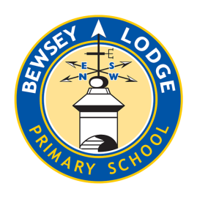
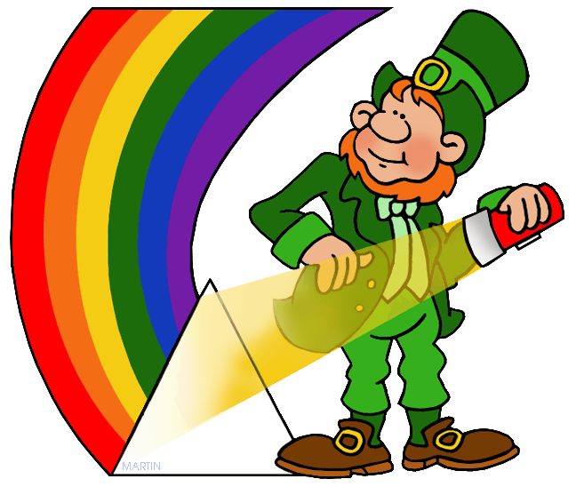
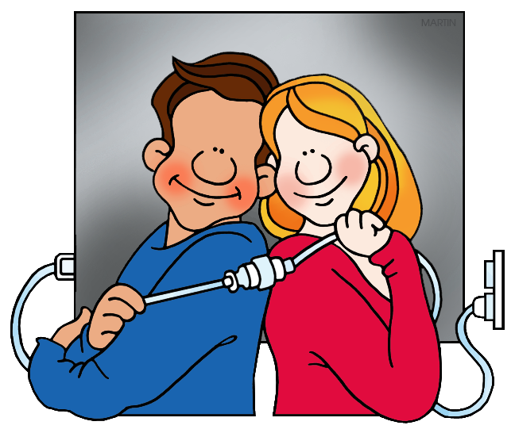
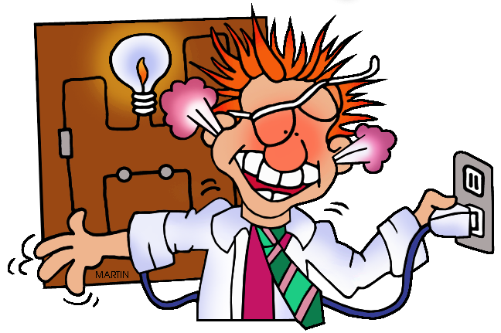

Choose your homework from the grid below:
You can choose as many tasks as you like. If you need a book or paper to record your work, just ask. You have the whole half term to choose and complete.
Return on Monday 13th July for marking and a reward

Try to attempt at least one task from the top line
Amethyst – Fizzics

Write an explanation of Sir Isaac Newton’s ‘Rainbow’ or colour theory.  Make it informative and include images to help explain how light works. | Write a formal letter to Mrs Wright highlighting the importance of saving power and switching things off when not needed.  Use a letter layout, remembering key features. | Make an eBook or PowerPoint presentation about animal eyes and how animals see, using drawing, pictures and/ or photographs.
Make a ‘lemon’ battery.  Find information on YouTube and ask an adult to help. | Make a shadow puppet to show in class.  No rabbits allowed | Create an information/warning poster telling people how to stay safe around mains electricity.  Carefully consider the potential hazards.
Electricity is expensive - make two separate lists of battery and mains powered items in your home.  What type of batteries are used?  Punctuate your lists correctly. | Do you have a Smart Meter? Record your daily electricity use over a week and create a line graph.  Remember to label each axis. | Create 10-15 challenging quiz questions about electricity.  Write the questions with correct answers.
Research some optical illusions and then bring them in to share. | Make up a mnemonic to help you remember the order of the colours of the rainbow.  e.g. Richard Of York Gave Battle In Vain. | On a sunny day take pictures of your shadow at two hourly intervals. Why does it change? Why don’t shadows have colour?  Send images to  amethyst@bewseylodge.co.uk

