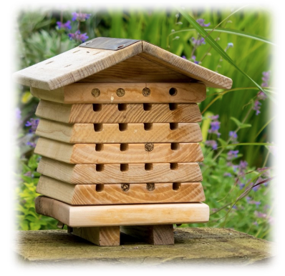
Interesting Facts
- Hedgehogs are nocturnal animals and only come out at night!
- Bees do a dance to show the other bees where the flowers are!

Vocabulary

Environment – The environment includes everything living and everything non-living

Protect – The act of keeping something safe from harm or the condition of being protected.

Sustainability – Sustainability is about small changes we can make to help look after the planet.

Wildlife – Wild animals living in their natural environment.

Pollination – transferring pollen grains from the male anther of a flower to the female stigma.

Colony – a group of bees living together

Habitat – the place where living things naturally live and grow
Topic overview
In this geography and science topic, children will learn about the wonderful world of bees and hedgehogs!

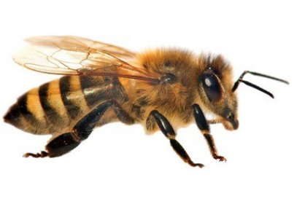

Key Concepts
- Types of bees and hedgehogs
- The best location for beehives and hedgehog homes
- How we can help bees and hedgehogs
- Important wildlife in our gardens
- Fieldwork and mapping skills

Key People
David Attenborough – Famous scientist and conservationist.

Andrew Ellis – The hedgehog man from Birchwood Hedgehog Rescue, devotes his time to caring for poorly hedgehogs.



