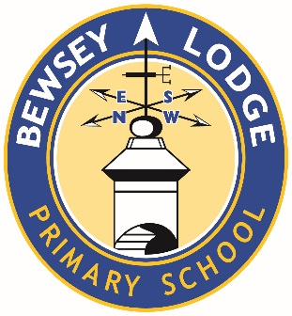

CONSENT FORM – PUPIL PERSONAL DATA
During a pupil’s time with us we will gather information about them which we will use for various purposes. As a Parent/Carer, you will have been provided with a Pupil Privacy Notice in relation to the use of this information, which is also available on the School website:
http://www.bewseylodge.co.uk/reports/privacy_notice/
There are some things that we cannot do unless you tell us that we can. We have set these out in the table below. Please could you read this form very carefully and tick as required. This will let us know if you have provided or refused consent.
- If you decide to refuse your consent then this will not affect your child’s place at the School
- You are completely free to refuse to provide your consent
- You do not have to provide reasons for refusing your consent.
Photographs and Videos
We assure you that we take very seriously the issue of potential misuse of photographs and videos of our pupils, and have the following measures in place:
- We only use the photos and videos of children of whom we have consent
- At the start of all public performances and events held in School, we request that photos and videos are not shared on social media without gaining consent from parents
- Storage of photos and videos meet data protection requirements.
The School may provide photographs and videos to the media, or the School may be visited by the media who will take videos and photographs. When these have been submitted to or taken by the media the School has no control over these.

Pupil Name: __________________ Date of Birth: _____________

Celebrating Your Child’s Achievements, Reporting on Events and Promoting the School
As a School we are very proud of the achievements of all of our pupils, and we want to be able to celebrate these achievements both within the School and with others. We may also want to report on significant events which involve our pupils, such as visits from dignitaries. This will involve providing information about involvement in certain activities such as sports.
I consent to School sharing the following information | Tick here
- Photographs and videos of my child
- Name, Class and Year Group alongside these photos and videos
- Images of my child on:
  - Internal screens and noticeboards
  - School website
  - School Facebook
  - Local or national news media – newspapers, websites and television
  - Promotional material such as the School Prospectus
I refuse consent to School sharing the above information | Tick here

You may change your mind in relation to your decision at any time. This includes withdrawing your consent to anything that you have agreed to here.
To withdraw your consent, or otherwise amend your position, please write to us at:
Data Protection Officer, Bewsey Lodge Primary School, Warrington, WA5 0AG
This consent will otherwise continue until your child leaves the School.

Signed: __________________________________
Name: __________________________________
Date: __________________________________

