BEWSEY LODGE PRIMARY SCHOOL

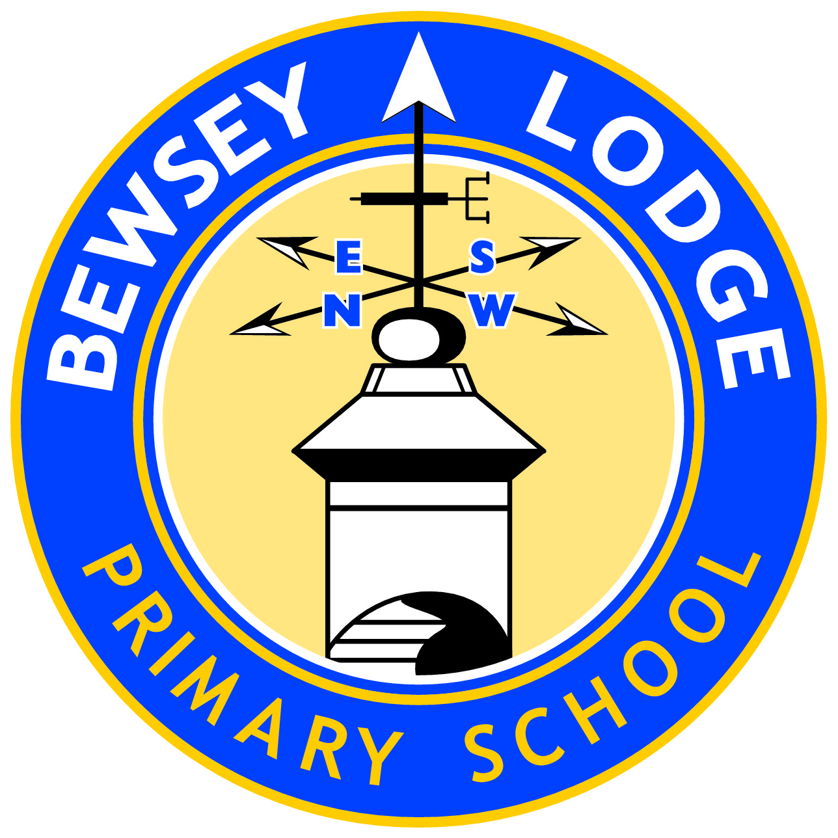

HEALTHY RELATIONSHIPS EDUCATION POLICY

Date of Review | November 2017
Date of next Review | November 2020

Bewsey Lodge Primary School

Sex and Relationships (SRE) Policy

This policy has been developed in accordance with Dfes SRE guidance 2000 and Warrington guidance for writing an SRE policy 2010.

Sex and relationship education is lifelong learning about physical, moral and emotional development. It is about the understanding of the importance of loving and caring relationships, including same sex relationships. It is about the teaching of gender, sexuality, sexual identity and sexual health.

Research demonstrates that good, comprehensive sex and relationship education does not make young people more likely to become sexually active at a younger age.

Sex and Relationship Education Guidance
(DfE 0116/2000)

Date of Policy: November 2017

Member of Staff responsible: Sarah Hopson

Date of next review: November 2020

Context of the Policy.

Our Shared Beliefs about SRE. In our school we believe:

• SRE is lifelong learning about ourselves including our emotions, self-esteem, relationships, rights and responsibilities, sexual behaviour, sexuality, sexual identity and sexual health. It takes place in many contexts: at home, at school and in the community.
• SRE is an entitlement for all young people. Difference and diversity must be taken into account when delivering SRE. Special educational needs or disability, gender, gender identity, sexual orientation and age, nationality, religion, cultural and linguistic background, all affect access to SRE.
• SRE is most effective when provided in the wider context of social and emotional development. In schools, successful SRE is firmly rooted in personal, social and health education (PSHE).
• SRE must enable young people to gain information, develop and transfer skills and explore attitudes and values, in order to support informed decision-making.

Aims and Objectives of the Policy

The aim of this SRE policy is to provide a working document giving clear guidance to governors, staff and parents on what is delivered, why its delivered, how it will be delivered and when it will be reviewed.

It is our aim, for sex education at this school to:

- encourage exploration of values and moral issues, consideration of sexuality and personal relationships and the development of communication and decision making skills;
- foster self-esteem, self-awareness, a sense of moral responsibility;
- emphasise the importance of relationships with, respect for and responsibilities towards other people;
- respond appropriately and sensitively to children’s questions as they arise;
- prepare for change - relationships as they approach puberty - move to secondary school;
- emotional problems as bodies develop;
- to develop skills in order to empower pupils to make positive decisions about their health related behaviour.

This should take place with consideration of the qualities of relationships within families of all different types.

Content of the SRE programme

Legal requirements

All schools must teach the following as part of the National Curriculum Science:

National Curriculum Science

In Key Stage 1, children will learn:
- that animals including humans, move, feed, grow, and use their senses and reproduce;
- to recognise and compare the main external parts of the bodies of humans;
- that humans and animals can reproduce offspring and these grow into adults;
- to recognise similarities and differences between themselves and others and treat others with sensitivity.

In Key Stage 2, children will learn:
- that the life processes common to humans and other animals include nutrition, growth and reproduction;
- about the main stages of the human life cycle.

RE and PSHE/Citizenship

In Key Stage 1, children will learn:
- to reflect on family relationships, different family groups and friendship;
- about rituals and traditions associated with birth, marriage and death;
- to discuss emotions which may be associated/involved in these rituals and traditions;
- to co-operate with others in work and play and begin to recognise the range of human emotions and ways to deal with them;
- about the importance of personal hygiene to maintain good health and they learn about aspects of personal safety including online and social media safety.

In Key stage 2, children will learn:

to develop a deeper understanding of relationships within a family, between friends and the community and that there are different patterns of friendship;

to develop skills needed to form relationships, including same sex, and to respect other people’s emotions and feelings;
- to consider how to make simple choices and exercise some basic techniques for resisting pressures;
- about the importance of personal hygiene to maintain good health and they learn about aspects of personal safety including online and social media safety.

At key stage 2 our main focus is preparing pupils for puberty. There is a strong emphasis on the emotions that come with this major change. Pupils will be able to express their opinions whilst respecting others points of view. They will be able to recognise the different relationships they are in and understand that their actions, both physical and verbal, have consequences.

Teaching and Learning in SRE.

Where is SRE delivered in the Curriculum?
Sex and relationship education is delivered through Science, RE, PSHE, Citizenship, Literacy activities Assemblies and circle time. Content dependent, this subject maybe delivered by classroom teachers, teaching assistants and if appropriate, outside visitors such as the community nurse.

A range of teaching methods which involve children’s full participation are used to teach sex and relationship education. These include use of video/DVD, discussion, looking at case studies, drama and role-play.

Mixed and/or single sex groups?

Sex and relationship education is usually delivered in mixed gender groups; however, there may be occasions where single gender groups are more appropriate and relevant.

In year 5/6 the school nurse will be invited into school to work with the children in single gender groups on preparing for puberty.

Links with other policies

This policy is linked with the following policies:
PSHE & Citizenship
Equal Opportunities
Safeguarding Children/Child Protection
Confidentiality
Behaviour
Anti-Bullying

Informing parents of the content and the right to withdraw

Parents are informed about all curriculum content through a parent information booklet which is also available on the website.

Legally, if they wish, parents can choose to have their child withdrawn from lessons they feel are unsuitable for their child at that time.

We use an “opt-out” system. Parents must inform school at the start of the half term when they wish their child to be withdrawn – this must be submitted in writing.

In Years 5 and 6, where subject content becomes more specific and sensitive, parents will be informed in writing before any lessons on take place. Lesson planning and resource materials will be available for parents to view and the right to withdraw, as above, still applies via an ‘opt out’ form.

Procedures for pupils who are withdrawn from sessions

If parents take up their right to withdraw their child, the school will endeavour, wherever possible, to provide the parents with the necessary information and materials in order that they may work with their child as they feel appropriate.

The child will be placed in another classroom and provided with work which they can complete for the duration of the sessions. Pupils should not be removed from school.

Answering questions

It is essential that ground rules (set by the pupils themselves and by the teacher) are agreed at the beginning of each topic in order to allow for the asking or answering of sensitive or difficult questions.

Where appropriate, there will be the facility to enable the use of anonymous questions, for example, a worry box can be used as a distancing technique, however, this will be at the discretion of the class teacher.

Teachers will endeavour to answer questions as honestly as possible but, if faced with a question they do not feel comfortable answering within the classroom, provision would be made to meet the individual child’s needs on a one-to-one basis.

Safeguarding Children / Confidentiality

Teachers need to be aware that effective sex and relationship education, which brings an understanding of what is and is not acceptable in a relationship, may lead to disclosure of a child protection issue. The staff member will inform the Head Teacher /Designated Child Protection person in line with the LA procedures for safeguarding children.

A member of staff cannot promise confidentiality if concerns exist.

Dissemination of the Policy

The SRE policy will be made available on the Bewsey Lodge School website. A paper copy will be available on request. The policy will also be shared with staff and Governors.

This updated policy was presented to governors in December 2016.
Date of next review December 2019.

Appendix 1

Puberty- We will teach about puberty in Years 5 and 6, in accordance with our Curriculum for SRE taken from The Matrix curriculum. This will cover aspects such as:
Year 5
- Physical differences between girls and boys including menstruation;
- Labelling body parts including reproductive organs;
- Exploring mood changes during puberty;
- How the body changes as they approach puberty;
- Exploring the impact of puberty on relationships.
- Understanding of reproduction, conception, foetal development and birth;

Year 6
- Recap above;
- Discussion around the explanations for the changes in emotions during puberty;
- Discuss the importance of loving, stable relationships, these may include same sex relationships;
- Discussions around growing up;
- Contraception – how it is used, where it is available and how it can prevent STI.

Younger children may be aware of puberty and we will answer their questions appropriately on an individual basis. We recognise the importance of ensuring that both boys and girls have a good understanding of puberty before they reach it.

We may use single sex groups to address particular needs, such as girls’ practical need for information about managing periods. We may work with groups of Year 5 and Year 6 pupils separately to ensure they receive appropriate information at these age groups.

We will ensure that sensitive arrangements are made for girls who have started menstruating. This includes the provision of sanitary disposal units and the discreet provision of ’Sanitary protection’ will be used. Staff will respond to such requests discretely, in a helpful way without embarrassment.

Contraception- We recognise that many primary-aged children are aware of some forms of contraception and have begun to understand that adults do not only engage in sexual activity when they wish to reproduce. Children may ask direct questions about contraception, or may reveal knowledge (accurate or inaccurate) about contraception in discussion with adults or their peers.
We will refer to guidelines for responding to these questions as outlined in the school’s SRE Policy. We will answer children’s questions in general terms and will ensure that our answers reflect the responsible choices adults make in deciding when to have children. This will enable pupils to further understand the responsibilities of adult life.

The learning will be set in the context of responsible parenting decisions. It will include details regarding access to or application of contraception.

There are extremely rare occasions when an adult in a primary school may believe that a child’s question about contraception derives from a child’s own sexual activity or contemplation of sexual activity. In this case, the adult will consult immediately with the designated teacher for child protection, who will make sensitive arrangements, ensuring there has been discussion with the child and explanation of the Confidentiality Policy, to involve the child’s parents and, if necessary, other professionals.

Abortion- We recognise that some children might be aware of abortion and that they might be developing attitudes towards it. They may also ask questions about it. Adults in schools will acknowledge these questions and respond generally to factual enquiries on an individual basis, rather than in a whole class discussion.

Sexually Transmitted Infections (STI’s) and HIV/AIDS-
We will teach about STI’s during the sessions in Year 6 relating to contraception. We will respond sensitively to questions posed by children. Teachers will use their professional judgement and guidance available to ensure their responses are factually correct and appropriate to the age of the child. Teachers will also acknowledge these questions and respond generally to factual enquiries on an individual basis, rather than in a whole class discussion.

Sexual Identity and Sexual Orientation We understand our responsibility to ensure that SRE meets the needs of all our pupils. Whatever their developing sexuality, children must feel that SRE is relevant to them and sensitive to their needs. Discussion around sexual orientation and sexuality, will take place (usually) during sessions on relationships. It will be acknowledged that many children will be aware of both heterosexual and homosexual relationships and may ask questions about these. We will answer these questions factually, in a general way, seeking to challenge prejudice. We will discuss different family arrangements, including same sex partners, when considering relationships. If we encounter examples 10 of homophobic language or attitudes we will challenge these.

Incidents of homophobic bullying will be dealt with according to our Anti-Bullying Policy which explicitly refers to homophobic bullying.

